**EXPERIMENT 5**

**DDL COMMANDS (COLLEGE SCHEMA)**

**Aim:**

* Create a schema called College.
* Create tables for students (attributes: student id, name, gender, subject, marks and grade), faculty (attributes: faculty id, name, course and pass percentage), department (attributes: department id, name, section, strength and pass percentage) and activity (attributes: activity id, name, strength and category)
* Add and modify:
  + Address in students table, change datatype size of student name and make student id primary key
  + Add faculty total mentor details, make faculty id as primary key
  + Add number of students in wise in department table and make department id as primary key
  + Add faculty name to activity table, change the datatype size of activity name and make activity id as primary key**.**

**Components:**

* Entity: Object that is relevant to the given system. It is representing as a rectangle.
* Attribute: Trait of an entity, relationship or other attribute. It is represented by oval.
* Primary Key: A primary key is a set of columns or a set of columns in a whose uniquely identify row in a table.

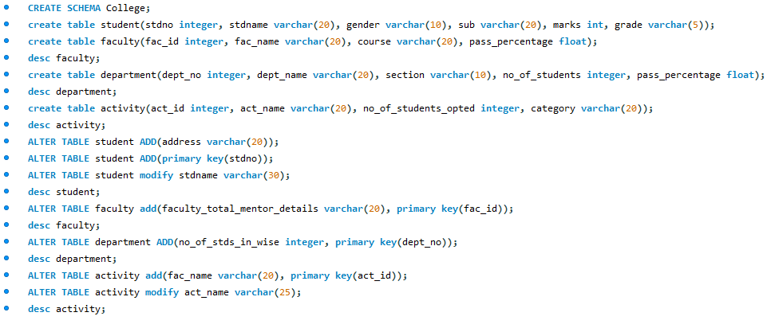

**Output:**

